Dear colleagues!

We are pleased to invite you to take part in the
VI All-Ukrainian Scientific and Practical Conference with International Participation "Chemistry of Natural Compounds", which is scheduled to be held from 27 to 28 October, 2022 online

We will be glad to welcome you to the
I. Horbachevsky Ternopil National Medical University, Ministry of Health of Ukraine.

The conference is included in the Register of Conferences of the Ministry of Health of Ukraine No. 592, which will be held in 2022.

SCIENTIFIC PROGRAM:
- Research of the chemical composition of medicinal plant materials and the prospects of creating medicines and dietary supplements based on it.
- Research of pharmacological properties and safety determination of herbal medicines and dietary supplements.
- Standardization and organization of the production of medicinal products and dietary supplements of plant origin.
- Market analysis of medicinal products of plant origin, dietary supplements, therapeutic and preventive and cosmetic products.
- Molecular mechanisms of action of biologically active substances of plant origin.

27.10.2022
9⁰⁰-10⁰⁰ – Registration
10⁰⁰-14⁰⁰ – Plenary meeting
14⁰⁰-15⁰⁰ – Coffee break
15⁰⁰-18⁰⁰ – Sectional meeting

28.10.2022 р.
10⁰⁰-14⁰⁰ – Trainings (Prof. Zaichenko H. V., Prof. Kyslychenko V. S., Prof. Oleshchuk О. М., Prof. Matveieva О.V.)
14⁰⁰-15⁰⁰ – Coffee break
15⁰⁰-16⁰⁰ – Closing ceremony

Publication form:
Please note that, abstracts sent to the conference will be published in book of abstracts (requirements are attached) (electronic version).

Forms of participation:
• oral report
• free listener

Official language of the conference:
• Ukrainian
• English

Regulations of reports:
• plenary report - up to 30 minutes;
• section report - up to 10 minutes;
• discussion - up to 5 minutes.

Please confirm your participation 1 month before the start of the conference.
Deadline for Abstract Submission: September 30, 2022.
The book of abstracts (electronic edition) and participant's certificate will be sent within a week after the date of the conference.

GUIDELINES FOR ABSTRACTS
- The abstracts should contain new, previously not published scientific results that are closely related to the areas specified in the call for papers, written in Ukrainian or English.
2. Please follow these guidelines during the preparation of an abstract:
– Materials should be sent in "* .doc" or "* .rtf" format.
- all margins are 2 cm, Times New Roman font, 12 pt, line spacing - 1.0, paragraph indent - 1.25 cm, spacing before and after the paragraph - 0 pt (absent), width alignment;
- the total volume of abstract (A4 format), including tables, figures and a list of references, should be 1-2 full pages;
- abbreviations of words and terms in the title of abstract are not allowed; Abbreviations in the text are deciphered after the first mention. Please use the SI system of units.
3. Abstract materials must be submitted in the following sequence:
a) title of abstract in capital letters;
b) surname and initials of the authors;
c) the affiliation of an author;
d) the abstract must clearly indicate the problem, objectives, research methods, results and conclusions.
4. Abstract will undergo a review procedure with the participation of specialists from the specified scientific areas.

Author Information
Please indicate the author's first name and surname, position, scientific degree and academic title, postal address, contact phone number, e-mail address, on a separate line you need to indicate the desired type of presentation of your work (only printing, printing and presentation on conference).

PARTICIPATION IN THE CONFERENCE IS FREE

Abstracts for conference should be submitted online at https://conference.tdmu.edu.ua/index.php/HPS-2022/ . Also duplicate to the email address farmokog_medbot@tdmu.edu.ua (materials must be sent together with the Author Information).
The submitting author, who is generally the corresponding author, is responsible for the manuscript during the submission and peer-review process.

Information system OPEN CONFERENCE SYSTEMS at: http://conference.tdmu.edu.ua

INFORMATION FOR PARTICIPANTS

VENUE OF THE CONFERENCE:
I. Horbachevsky Ternopil National Medical University, Ministry of Health of Ukraine

THE ORGANIZING COMMITTEE
Scientific Department, I. Horbachevsky Ternopil National Medical University, Maidan Voli, 1, Ternopil, 46001

CONTACT INFORMATION:
Head of the Pharmacognosy and Medical Botany Department,
D.Sc, Professor Svitlana Marchyshyn,
farmokog_medbot@tdmu.edu.ua, marchyshyn@ tdmu.edu.ua

Head of the Pharmacology and Clinical Pharmacology Department
D.Sc, Professor Oleksandra Oleshchuk
oleshchuk@tdmu.edu.ua

Research Office (organization of scientific forums)
Head of the Research Office – Prof. Oksana Shevchuk
Specialist – Tetiana Bisovska
+38(0352) 52-04-79
vonf@tdmu.edu.ua

Web site: www.tdmu.edu.ua

MINISTRY OF HEALTH OF UKRAINE
I. HORBACHEVSKY TERNOPIL NATIONAL MEDICAL UNIVERSITY

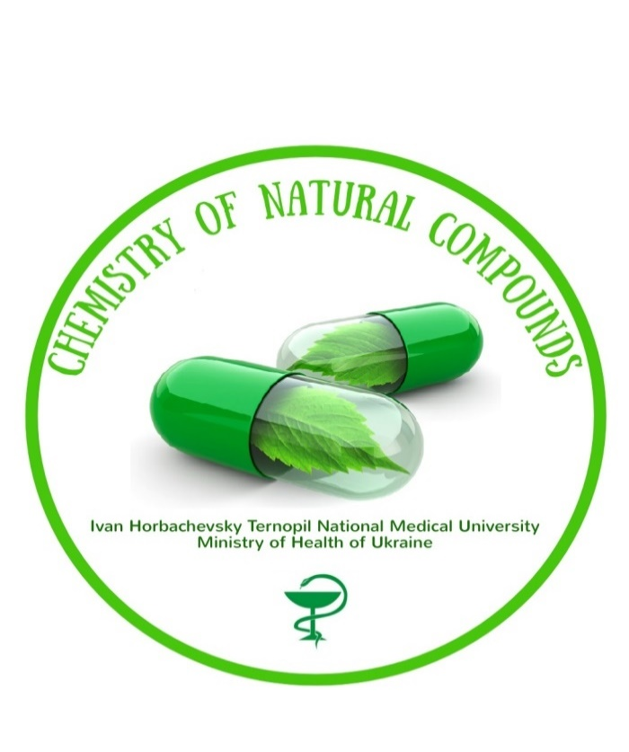
VI All-Ukrainian
Scientific and Practical Conference
with International Participation

"CHEMISTRY OF NATURAL COMPOUNDS"

27-28 October
2022

Ternopil, Ukraine

